Developing Computational Thinking Skills through the
Literacy from Scratch project
An International Collaboration

Paper given at the IFIP Conference in Vilnius, July 2015
Authors:

Miroslava Cernochova, Charles University, Prague, Czech Republic

Miroslava.Cernochova@pedf.cuni.cz
Mark Dorling, Computing at School, 5 Southampton Street, London, UK
Email: mark.dorling@computingatschool.org.uk
Lawrence Williams, Senior Academic Fellow, MirandaNet, UK
Email: lawrencewilliams@mirandanet.ac.uk

Abstract
This paper builds on the growing international success of the Computing project, Literacy from Scratch, showing how computational thinking skills (mainly algorithmic thinking at this early stage) can be developed through this creative, cross-curricular project. The project is now established in several countries (in the UK, the Czech Republic, Italy, and Pakistan) and it has been presented in several more (in Poland, Germany, Sweden, Turkey, and Korea). However, while it provides an excellent starting point for the development of computational thinking in schools, there is now a clear need to show teachers how computational thinking can be incrementally developed through this project, and underpinned by research. Accordingly, this paper looks at the practicalities of the project itself, and suggests ways in which the Progression Pathways (an assessment framework with a set of incremental skills, concepts, and principles) set out in England by Computing at School (CAS), and researched and developed in the Czech Republic, can begin to be mapped.

The Literacy from Scratch project is supported by a dedicated website in several languages: www.literacyfromscratch.org.uk and has an accompanying Routledge text book, “Introducing Computing” ed. Lawrence Williams, with chapters by Miroslava Černochová, and Mark Dorling.

Progression Pathways assessment framework can be found at:
http://community.computingatschool.org.uk/resources/1692 and were developed by Mark Dorling, and others at Computing at School.

Key Words
Computing, programming, progression, creativity, cross-curricular learning, Scratch, story-telling, the pupil´s concept of a computer, assessment framework

Introduction
In many countries across the world, new attention is being given to computing and computational thinking in schools. In England, this is being driven by a new government curriculum initiative, called Computing. By contrast, some countries, like the Czech Republic, are not waiting for governmental instructions, but are attempting to introduce computational thinking into their curriculum, quite independently. A Computing project, which has successfully engaged school pupils and teacher trainers in both of these countries, is called Literacy from Scratch. It is an example of a very fruitful international collaboration between primary and secondary schools, and teacher training institutions in England and the Czech Republic. While the concept of developing computational thinking is the same in both countries, there have been different approaches to the pedagogy and research methods underpinning these relatively early stages of the project.

This paper therefore explores the development of computational thinking through two slightly different case studies. Both countries, however, are united in their desire to develop the computational thinking skills of their pupils, and in their passion for cross-curricular teaching and learning.

- Case study in the UK
The teaching of the new subject, Computing, as it is now called in England, as a part of the National Curriculum, has only been undertaken since September 2014. Prior to this, Computing, which includes aspects of ICT, e-safety, as well as computer programming, was taught in some schools as a lunch-time activity, or in after-school clubs. Some teachers have been utterly dismayed by the seemingly impossible demands of the new Programmes of Study for Computing, though many others are nonetheless enthusiastic to learn. But how can these teachers suddenly develop a wide range of new skills in Computing? Can our pupils, aged from only 5 years, really understand, write, and debug computer programmes?

Some of us are of a generation that remembers, through concrete experience, the wonderful cross-curricular, collaborative, and creative projects undertaken in our Primary schools (age 5 to 11), a process sadly destroyed by the introduction of the National Curriculum in the 1990s. By using Scratch, a graphical programming language, as the tool, however, we have the opportunity to replace this lost teaching model, while simultaneously introducing the new Computing curriculum. This is an exciting prospect.

The opening paragraph of the National Curriculum states, “A high-quality Computing education equips pupils to develop computational thinking and creativity, in order to understand and change the world.” Here is a reminder of what UK pupils, aged 5 and 6 (Key Stage 1), must be able to do:
- Understand what algorithms are, how they are implemented as programs on digital devices, and that programs execute by following precise and unambiguous instructions
- Create and debug simple programs
- Use logical reasoning to predict the behaviour of simple programs?
- Use technology purposefully to create, organise, store, manipulate and retrieve digital content?
The starting point for the journey into Computing, therefore, is clear.
The picture below captures much of this initial process, and starts the pupil on the journey towards computational thinking. Look carefully at the picture:

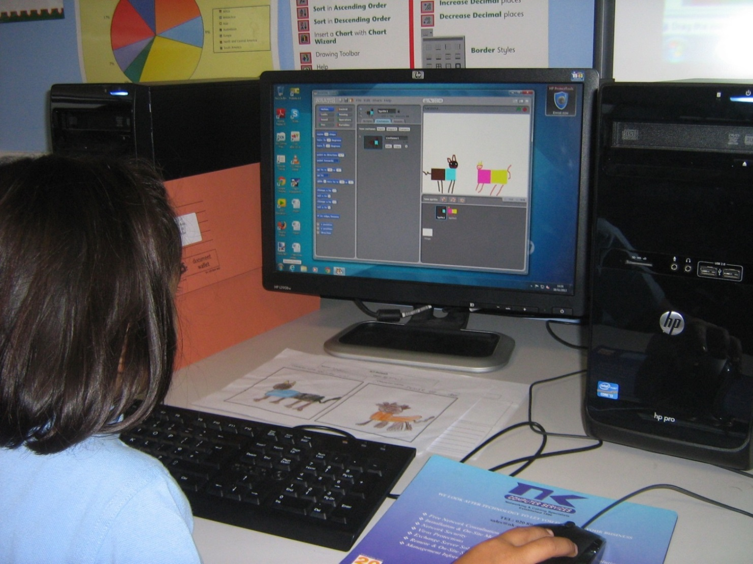
Figure 1. A KS1 pupil, age 5 years, creating Sprites for her Scratch story (Swaminarayan School, Neasden, West London)

On the left is an orange folder with the pupil’s story in it. This material was prepared during her English lessons, following literary stimulus lessons from her teacher. In front of her, on the desk, is a draft picture of the two characters which she hand-drew for her story, in her Art lessons.

On the screen is a digital version of her characters, made in the Paint section of Scratch.

Each pupil in Year 1 and in Year 2 (age 5 and 6) then created two story characters (Sprites) and three background scenes (for the Beginning, Middle, and End structure of their stories). Simple, two colour-wash backgrounds work best.
Each pupil programmed Scratch to change from scene one, to scene two, and then to scene three.

Each pupil then added a simple animation effect for one, or more, of the characters.

On the web are several stories created in this classroom, as examples. See: http://www.literacyfromscratch.org.uk/pupils/ks1.htm

Some pupils also added “voice-over” sound files in various languages. All of these files can be downloaded and deconstructed, so that teachers and pupils can see how they work.

The web site: www.literacyfromscratch.org.uk has been developed specifically to explain this whole process, giving completely cost-free support consisting of help sheets, lesson plans, schemes of work, pupils’ work, teachers’ work, evaluations, and pedagogy. The project now runs also in the Czech Republic, in Italy, and in Pakistan, so some of the materials are in these, and other, languages. The web site has two search engines to help teachers and pupils to find what they need. We are currently actively developing bilingual stories as teaching materials for teachers of second languages, as well as adding music, to join the art, computing, and literacy work.

Above all, we had great fun making our stories, and animating them at KS1, KS2 and at KS3, within a structured teaching and learning environment.

Here are some comments by one of the teachers from a school in which we developed these materials. Donna Roberts (a Year 1 teacher) writes:

“I never thought that five-year old students would be able to progress as quickly, and with as much innovation, enthusiasm, and focus as my students have. They are all so proud of their work, and we hope our experience will aid you in assisting your students along their Scratch journeys towards success in the new Computing curriculum. The best advice I can give you is to embrace the concept of programming, and allow your students to work at their own pace, while giving them enough skills and information in order for you to give support to the ones who require it, while allowing the more able children the freedom to explore their abilities through the knowledge they possess, and develop. At times, quite frankly, this process has been frustrating, with multiple hands in the air, and students calling out, “Miss Roberts! I need your help!” But I have seen such a massive progression in their skills that the calls have now become, “Miss Roberts! Look at what I can do!”

Teachers who have adopted this Literacy from Scratch teaching and learning model, in the UK and abroad, have been amazed at how exciting the project can be, and, perhaps more importantly, how they can so easily develop creative writing, art, music, and Computing skills, all at the same time.

However, this project, Literacy from Scratch, was devised originally by a teacher of English, rather than of Computing, and while it certainly works extremely well in getting former ICT and other teachers “off the mark” in Computing, and using Scratch to meet the demands of the new National Curriculum, the project simultaneously has to be able to encourage pupils to develop their computer programming skills in a broadly incremental way. This necessary progression requires a more rigorous Computing approach, and for this we turn to Computing at School’s National CPD Co-ordinator, Mark Dorling. He has, with colleagues, developed Progression Pathways, a thorough “map” of the key Computing concepts that schools in England should aim to develop.

The full Progression Pathways grid can be found at:

http://community.computingatschool.org.uk/resources/1692

This has had over 20,000 downloads, and is fast becoming the “gold standard” in English schools, as it was included in the Department for Education (DfE) and Microsoft funded QuickStart Computing project.

1.1 Concepts of Computational Thinking and Computing

Here is a snapshot of part of the Progression Pathways. The next section of this paper explores how the Literacy from Scratch project can help to meet these incremental requirements.
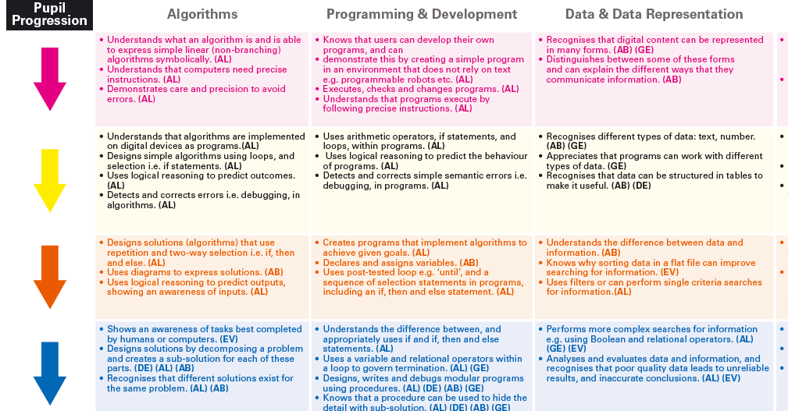
Figure 2. Part of Progression Pathways

The Literacy from Scratch project and Progression Pathways

This project was conceived as a cross-curricular response to the new government Computing initiative. As such, it covers all of the requirements for the first level of Progression Pathways, which includes the three main elements:

Computer Science (CS), Information Technology (IT) and Digital Literacy (DL)
The main focus for English schools, which already teach IT and DL, is therefore on Computer Science.

This, is turn, is divided into six main teaching areas:

Algorithms, Programming and Development, Data and Data Representation, Hardware and Processing, Communication and Networks and Information Technology

For the purposes of this section of the paper, analysis is confined to the first three of these pathways, as shown above.

Literacy from Scratch covers all six aspects of the curriculum requirements for Computing at a starting level. This level is coloured in pink on the grid (see on-line for the colour coding) of which three (Algorithms, Programming and Development, and Data and Data Representation) are shown. There is no statutory guidance on assessment, and the school inspectorate is not keen on levels. Therefore, use of colours allows teachers to assign any arbitrary value to colour, and focus on progression instead. The Progression Pathway statements have computational thinking opportunities mapped to them, in order to support teachers in identifying, recording, and auditing which computational thinking techniques they have been using. Mark Dorling and others have developed this CAS computational thinking framework. It is also worth mentioning that the CT Framework is at the core of the DfE and Microsoft funded QuickStart Computing project. There is therefore a clear structure and coherence behind the whole process.
This means that by adopting and developing Literacy from Scratch in their classrooms, many teachers have made a useful start to the new Computing curriculum, even if only at a (very manageable) first level.

1.2 Research methods
In England, as we are only just starting to develop Computing as a new curriculum subject, from September 2014, there can, necessarily, be little evidence of progression, as yet. Research is currently confined to Action Research, as shown on the web site: www.literacyfromscratch.org.uk . However, as interest in the project grows, we envisage this aspect developing further. It has already started in the Czech Republic.

There is some research underway regarding the Literacy aspects of the project. Raed Yacoub, a Ph.D. Research Fellow, School of Education, University of Greenwich University, London is currently working with two ESOL classes at a sixth Form centre in London, and is very keen to extend his research into schools, and work with EFL programmes, using Scratch. He is also working with one of the project’s pioneer schools, Swaminarayan School (primary), Neasden to see how far the project supports the purely literary aspects (i.e. story-telling). We are still at a very early stage.

1.3 Activities of pupils and teachers
But how are teachers to move their pupils’ levels from level one (pink) to level two (yellow) and on to level three (orange), and beyond? How is progression to be managed? Within the creative concepts of the project, can further progress realistically be made?

Here are some activities that may be included to extend computational thinking skills:

Loops and repetition (i.e. level two, yellow)
Loops can be developed in a number of ways. First, there is a very simple, cross-curricular way, through music. In order to create a musical background to the story, or a song within it, or a dance at the end of it, the Sounds section of Scratch can be a very useful ally. A song like the traditional “Good King Wenceslas” (well-known both in the Czech Republic, and in the UK), for example, has the repeated phrase:
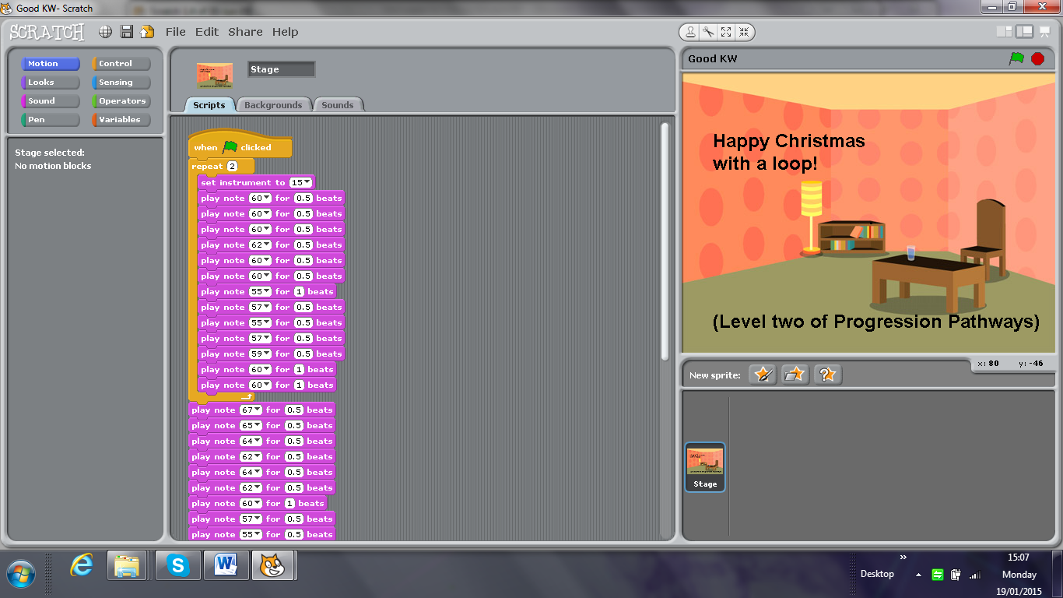
Figure 3. Programming music in Scratch

Why repeat writing out the coding when a simple loop (or repeat) can be used, as above? This, incidentally, was coded by a seven-year old pupil, who has clearly met the simplest algorithmic thinking statements (AL) already. More importantly, progression to a higher level in Computing is driven by adding music to the project.

But all sorts of animation effects can also be used as a stimulus for developing computational thinking. Children love to see effects in action, and so, for example, making an animated bat (which can be hand-drawn in an art lesson, or borrowed from the Scratch pool of animals) can be made to “catch an insect” (again drawn or borrowed), and class discussion, a very important aspect of computational thinking, fixes this in the mind of the pupil. This animation, can, in turn be developed as a mathematical concept, by using the x and y axes as a background. The bat can travel around the lines of a square until it touches an insect. (Prediction: What will happen if…? can also be added into the mix very easily.) Here, higher level thinking is also being driven by the needs of the actual story line, and its animation elements.

Subjects that might be included in the story-writing
These narratives can also be developed through a focus on topics such as the environment, and tied into UK primary curriculum concepts such as mini-beasts, and predator and prey, and linked with personal and social education (care for others) all linked through the Computing curriculum, the mechanism by which these stories unfold on the screen. Was there ever a better time to introduce computer science concepts into the curriculum?

Summary of the case study
Literacy for Scratch has engaged pupils in Computing from the age of 3 up to the age of 14, (and up to age 16 in Italy, through the work of G. Barbara Demo), and can do so in increasingly challenging ways. The project supports the development of creative narrative work, as well as cross-curricular thinking, by combining Literacy, Computing, Art, and Music. When allied also to subject material such as science (through science-fiction stories) or the environment, or social and moral issues (through stories about bullying, for example), it is clear that there is huge potential for cross-curricular teaching and learning, brought about through the development of the Computing curriculum.

2. Case study in the Czech Republic

Background
Currently, as we have suggested earlier, the whole world is discussing the implementation of coding, computing and programming, and devising ways of embedding these concepts and skills into the school curriculum, from many reasons. For us, as educators, the most important thing is how these topics can contribute to learning abilities, and to the understanding of digital technology. A requirement to develop computational thinking is talked about very often. J. Wing (2006) presented the concept of computational thinking as a way of “solving problems, designing systems, and understanding human behaviour by drawing on the concepts fundamental to computer science”. ACM (2011) understands the concept of computational thinking as “a problem-solving methodology that can interweave computer science with all disciplines, providing a distinctive means of analysing and developing solutions to problems that can be solved computationally". Bort and Brylow (2013, p. ) underline that “computational thinking is a method of problem solving, using abstraction and analytical thinking to arrive at a best answer. It is not about using a computer to solve a problem: it is more about thinking in an algorithmic way. All approaches to computational thinking concept highlight the same features: problem-solving, thinking activities, and their exploitation in different branches of human activity, not only in computer science and mathematics.

Unlike England, Australia, or Lithuania, the Czech Republic has not discussed computational thinking in the context of school education. Nevertheless, in 2014 this concept was integrated into a document Strategy for digital education for 2020 approved by the Czech Government on November 2014. Some Czech schools, inspired by experiences from abroad, are examining ways, and seeking to develop new approaches to ICT in education, and have started to concentrate on algorithmic thinking development. The project, Literacy from Scratch, is one example of how to start this international initiative.

2.1 “Tell your story and try to program it“
The starting point for a case study “Tell your story ...“, designed within the framework of Literacy from Scratch is based on several facts in the context of the Czech Republic:

- The position of ICT as a subject, and especially topics of algorithms and programming in the curricular document “Framework Educational Program for Basic Education“ (FEP BE)
The aims of ICT as a subject in the curricular document FEP BE (RVP ZV, 2013, s. 32) do not include the requirement to develop the algorithmic thinking of pupils, nor to dedicate any attention to their programing skills. These two concepts – algorithmic thinking and programming – are not mentioned and specified either in the curriculum, or as learning outcomes of particular themes of ICT in Basic education for pupils aged 6-15 (RVP ZV, 2013, p. 33-34), neither in a proposal of Standards for ICT as a school subject (Brdička et al., 2013).

ICT as a subject in FEP BE (RVP ZV, is focussed mainly on ICT user skills development, to be able to work with a computer and to search for information from different digital resources, including the Internet, and to publish and present them in different digital formats. A theme “Use of digital technology“ as a part of a school subject, “Being and world of work“ (RVP ZV, 2013, p. 84-89) also concentrates only on ordinary user activities essential for manipulation with digital technology.

- Algorithms and programming in school practice
Extensive research carried out among Czech ICT teachers at lower secondary education, in 2013, discovered, and at the same time confirmed, that the teaching of ICT as a school subject is focused primarily on work with the Internet (searching information, e-mail communication) and on fundamental user skills to use main SW (text-processing, spreadsheet graphics applications, SW for doing digital presentations) (Rambousek et al., 2013).

It was discovered that only a very few Czech schools in the Republic have been dedicated over a long period to algorithmic thinking and programming development (Rambousek et al, 2013; Černochová, 2010). This was reinforced also in interviews with 73 part-time students of MA degree study of ICT, who teach ICT as a school subject in Basic schools. The basics of programming are implemented in school education only by ICT teachers who have a technical professional background with a focus on computer science, IT, or who at some time worked as a computer programmer.

- Teaching approaches to pupil learning:
The theoretical basis for teaching approaches and to knowledge processes, more and more emphasises the importance of active and engaged learning, especially the importance of creating different types of artefacts, including mental artefacts (Slavík et al., 2014). And the process of computer program creation in schools, based on an appropriate educational programming environment, can play an important role in pupil learning, and in acquiring different literacies, such as mathematical literacy, reading literacy, linguistic or visual literacy, and including digital literacy.

Most Czech pupils (aged 6 to 15) do not come across any programming outside their school activities. This young generation has no idea about how it is possible for them to use a computer, and other digital devices, to carry out so many miscellaneous social activities (such as playing games, social communication, publishing, and searching for information). Unfortunately, pupils’ experiences with tablets amplify this fact. Work with tablets differs from a work with an ordinary PC. Pupils understand a computer as a tool for work with SW, as a tool for downloading programs, or browsing photos, for communication on Facebook, or searching for information on the Internet.

The first steps in a new governmental strategy for education in the Czech Republic:
Although there is no intensive discussion among teachers, teacher educators, researchers and policy-makers in the Czech Republic about the need to reform the existing curricular documents, and to implement into them the basics of Informatics or Computer Science, the incorporation of the requirement to develop computational thinking of pupils and their teachers into the governmental document Strategy for digital education for 2010 (Strategie digitálního vzdělávání do 2020, 2014, s. 46) was nonetheless achieved in 2014. The document was approved by the Czech Government on 12.11.2014. It seems to be an indication that the Czech Republic could be engaged very soon in the introduction of key Informatics/Computer Science concepts into school education (including pedagogical approaches to algorithmic thinking, and programming skills development) into curriculum and university teacher education and teacher continuing professional development. At present, the Czech Ministry of Labour and Social Affairs has started to collaborate with the Czech Ministry of Education, Youth and Sport about questions related to digital literacy (MPSV MŠMT, 2015).

2.2 Some data about a case study “Tell your story ...”

From September 2014 to January 2015 a research project was developed called, “Tell your story and try to program it” in Scratch, with two groups of pupils aged in 11 to 22, one group was formed of 22 pupils of Grade 6 at a Basic school and second one was formed of 14 pupils in the eighth-year gymnasium in Prague.

Lessons were organised regularly, 1 hour per week, in both schools (the Basic school and eight-year gymnasium) managed by the same ICT teacher in the framework of the compulsory ICT subject. The ICT teacher published her lesson plans, study materials for pupils and tutorials on her web pages (http://scratch.sandofky.cz). Teaching at both schools took place in computer labs, with data projection, and in a good working atmosphere.

The project “Tell your story”, was aimed not to research a teaching methodology for programming in Scratch for beginners, but rather, primarily, to start inquiry into the nature of pupils’ ideas about computers. The project strove to develop a complex of fundamental literacies (reading, visual, digital, linguistic, mathematical, and musical) with a special accent on cross-curricular links. On no account was there any aim to compare ICT knowledge and skills between two groups of pupils, that is, between Basic school pupils and eight-year gymnasium pupils.

Target group
The group from the Basic school was formed by 22 pupils (10 male, 12 female). The curriculum of this Basic school is focussed on pupil creativity development, and on creative teaching approaches to learning. Pupils of this Basic school are used to approaching tasks creatively not only in artistically-oriented subjects, but also in other subjects, including science. If pupils do not understand what they learn they show it by their behaviour. They were very spontaneous in asking questions, they enjoyed speaking, but sometimes they had problems in narrating stories. Some of them had a problem in concentrating on their work. Algorithms and programming are not included in the school curricular programme. Nevertheless, some pupils of Grade 6 did some programming in Scratch in the school year 2013/14. ICT as a school subject at this Basic school is focussed on creative work on computer, not on technological principles about how computers function.

The group of eight-year gymnasium was formed of 14 pupils (12 male, 2 female). The pupils were accepted to study at this selective school according to their success in their entrance examination. In ICT they are used to apply simple algorithmic procedures and logical thinking. They did not know Scratch before the start of the project “Tell your story ...”.

Research question
The research question concentrated on which ideas about computers the pupils should begin work with, in order for them to have an idea about how a computer works. Do pupils have any idea of how they will be able to program a computer, with the aim to fulfil their dreams, and to ask their computer to do what they wish? Will the pupils’ ideas about what a computer can do, and why it can do what it is able to do, change in any way if pupils spend some lessons working in a programming environment and thinking about how to instruct the computer to do what pupils want? Will pupils’ first programming experiences have any impact on their ideas about what they can do with a computer?

Research methods
To resolve this research question, we applied qualitative research methods, a systematic observation, questionnaire method, a test with matching tasks, a test with short answers, essay, interviews with pupils, analytic and synthetic methods for evaluation of pupils’ outcomes.

Carrying out the project “Tell your story ...“
At the beginning of the project the pupils were given a questionnaire with the aim of seeing their initial ideas about a computer.

From the questionnaires, we discovered that the pupils in Grade 6 from Basic school learn how to manipulate and use computers primarily from their siblings, from their parents and from other members of their family, and in many cases by themselves without any help. Approximately a half of the parents of this group of pupils (12 mothers, 12 fathers) work with a computer. Some pupils mentioned what activities their parents do on computers: Facebook, searching information, from doing enclose an invoice, to architectural design). In spite of the fact that pupils spend at home a relatively a large amount of time using computers or another digital device, the questionnaire, unsurprisingly, did not substantiate pupils having any profound knowledge about computers, or any clear idea about how computers work.

The pupils of the Grade 6 did not think at all about how and why a computer works, and 75% of them stated they had no idea about this problem. For some pupils, a computer works “accordingly to technology. It is a box full of ideas and thoughts.” “A computer functions thanks to a graphics card and to other components, but I did not think about it.” “According to my idea, it contains some components in which information is stored. And using wires it is transmitted to a monitor.”

Answers to the questions, “How can you communicate with a computer? How can you tell it what you want from it?” pointed towards what the pupils of the Grade 6 mainly do with their computers:

- They search for information on the Internet:
I write it to a search engine – I write to my computer what I am searching for, and it finds it – I write it to my computer – I write something , then I use ENTER and press OK – I move mouse on an icon (for example Google) and using keyboard I write what I need to know (for example a recipe how to bake a cake) or you can play games – it is handled by a mouse or keyboard – You can communicate with a computer writing using a keyboard.
- They work with SW applications
Using a keyboard and a mouse I click on what I need – I do not understand very much the question, but either I write it to my computer on a keyboard or I click by a mouse – I click everything using a mouse – I have a mouse and I click on everything what I want and need – Using a keyboard I write what I need and using a mouse I click on icons or items)
The pupils of the Year 1 at the eight-year gymnasium do not spend so much time using game consoles, and playing games. Their answers in the questionnaire demonstrate they have clearer and more complex ideas about how and why a computer functions, following a series of classroom lesson on hardware and software:

A computer can work due to electricity – it transmits a set of 1 and 0 which are displayed on a monitor or stored in a computer memory and its other elements. There will be presented a picture on a monitor, in memory cards there are stored all data, and a processor operates and controls all processes. – In a computer inside there is a hard disk where are stored all information about everything in a “binary language“ which operates with 0 and 1 only, everything is recorded in 0 and 1. By pressing A (B, C, ...) on a keyboard a signal passes in a binary form through a silicon board, and a graphics card to a monitor where it is displayed in a form recorded for this key.

The pupils from the gymnasium think a person can communicate with a computer that s/he “puts some things using a mouse or a keyboard into various programs, but if you want to program your own program you must formulate a complicated formula in a programming langue – to create the programme.” Some of them answered “The question is very simple – we put data and information into a computer through a keyboard, mouse, microphone ...(a touch monitor?)”. Understandably, there are some pupils who, similar to pupils of Grade 6 in their answers, mentioned „using a keyboard and mouse“. In pupils from the gymnasium opinions were: “a computer is able to do only what is being programmed for a computer. A computer may do only two things, but it can also do 5000 things or more – it depends what a person programmed the computer what to do.” “A computer knows to do many things, but it needs programs. A computer is used for calculating numbers, communication, entertainment, recording, writing, editing, processing photos, videos or sounds.“ Some pupils compared a computer to “a robot – it works according to our instructions, but it has no own opinions.” Another student wrote “we cannot compare a computer to anything. Each its form (calculator, mobile, etc.) is specific. A computer is an unique object.”

PHASE 1: Teamwork and scenario development
Lessons of programming in Scratch were based on pupil teamwork. Pupils formed two-members teams. Each team had its name. Pupils in teams proposed their own story which at the start they described in a written form as an essay; using four colour markers in each essay they had to mark out four phases (scene) of the story which related to the same background (stage). Then they presented a main idea of their story to all class verbally. After then, using worksheets they developed a structured storyboard with four scenes (Picture 1). They had to name each scene separately. Using a table for each scene pupils wrote a list of sprites. Finally, they again told the story in a written form in details structured by each scene.
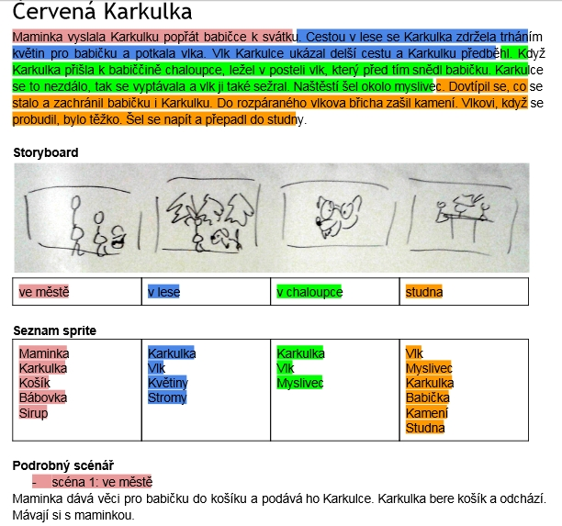
Picture 1 Example of structured scenario for a story „Little Red Riding Hood“
Pupils could draw inspiration from an example based on a Czech popular song „Skákal pes přes oves“. This example (Picture 2) was used as a teaching material to teach pupils to program in Scratch. Firstly, under teacher guidance, the pupils learnt how to analyse the program of this story, all they had a study material including a program in Scratch. Its melody which is very well known to each child helped pupils to understand a structure of the Scratch program.
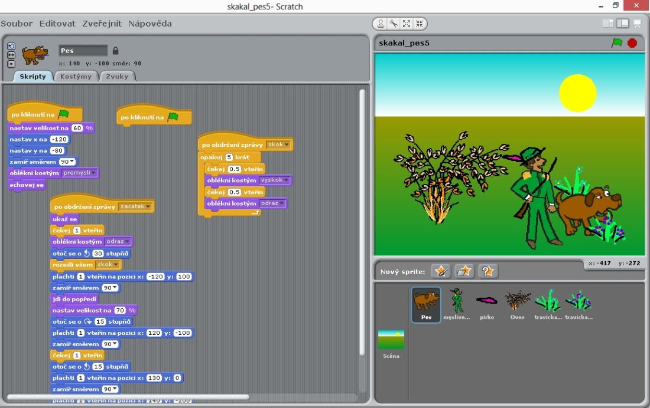
Picture 2 Example of a story based on the Czech song "Skákal pes přes oves"
PHASE 2: Teamwork in programming stories
Pupils were not allowed to use ready-made graphics and sprites available on the Internet. They had to design original graphics. We recommend pupils to edit sprites and backgrounds (stage) in Scratch editor or to draw graphics by hand on a paper and then to scan or to draw graphics using a graphic tablet. The majority of pupils designed all graphics in Scratch editor. Only one team scanned their own hand made pictures. In spite of all pupils tried to draw pictures using a graphic tablet, in the end nobody used it for their stories in Scratch.

Pupils of Grade 6 programmed in Scratch 12 different stories. For us it was very important that the pupils were interested in their teamwork because they programmed their stories which they had thought themselves. The progress of each team was assessed continuously: each team obtained in a printed form information and recommendation what would be better to do or change, how to solve some situations in their program (Picture 3). Pupils had to read these recommendations and instructions very carefully.
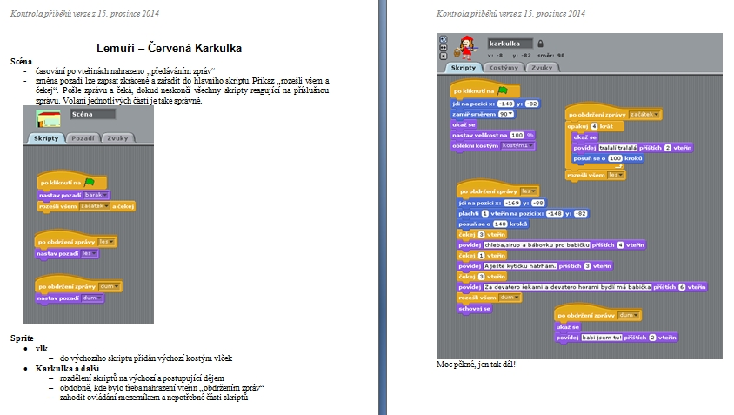
Obrázek 3 Recommendation for a teamw
PHASE 3: Explanation of key concepts related to programming
We exploited some experiences which pupils step-by-step have acquired in Scratch to explain to them some key concepts (algorithm, program, sequence of command, input, output, variable, cycle, branching, debugging) in a context of specific examples in particular situations (Picture 4).
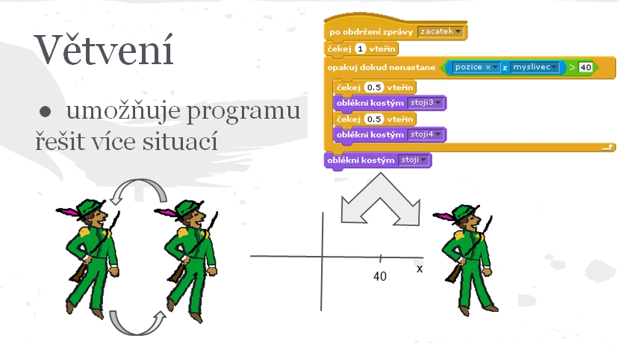
Obrázek 4 Explanation of a concept of Branching using a situation from a song Skákal pes přes oves

  - Concepts of Computational Thinking and Computing
  - Research methods
  - Activities of pupils and teachers
  - Summary

Conclusion
Literacy from Scratch as a classroom project for introducing pupils to computational thinking is succeeding because it allows non-specialist teachers (or rather teachers with other skills!) to begin working on Computing through a constructivist model. But it also allows for conceptual progression. Much still needs to be done to develop computational thinking further, of course, but, in Literacy from Scratch, we now have a creative and cross-curricular teaching and learning framework within which pupils and teachers can develop understanding and skills in a constructivist way, one which can be easily mapped against Progression Pathways and the computational thinking framework, and that is being effectively supported by research.

Resources
Key Competencies in ICT and Informatics. Implications and Issues for Educational Professionals and Management
IFIP Advances in Information and Communication Technology Volume 444, 2014, pp 25-33
A Working Model for Teacher Training in Computing through the Literacy from Scratch Project.
G. Barbara Demo and L.Williams, (2014). The Many Facets of Scratch, in Proceedings of the ISSEP Conference 2014, Istanbul, September 2014.

Progression Pathways
http://community.computingatschool.org.uk/resources/1692
CT Framework
http://community.computingatschool.org.uk/resources/2324
L. Williams and M. Černochová, (2013). Literacy from Scratch, in Proceedings of the 10th IFIP World Conference on Computers in Education (Torun, Poland, July 2-5, 2013) WCCE 2013. Copernicus University, Torun, PL, 17-27.
For the supporting text to the project, see:

Lawrence Williams, Ed., “Introducing Computing: a guide for teachers”, Routledge, August 2014
http://www.routledge.com/books/details/9781138022850/

For the supporting web site for the project, see:
www.literacyfromscratch.org.uk

Contributors:
Miroslava Černochová – Charles University in Prague
Miroslava works, as Vice Dean of Education, for the Faculty of Education at Charles University in Prague, Department of Information Technology and Technical Education, where she is responsible for courses focused on Pedagogy of ICT in Education, Teaching Practice of ICT student teachers, and on Teaching of ICT as a compulsory educational area for Primary and Secondary Schools.

Mark Dorling - National CPD Coordinator (UK), Computing at School
Mark has a first-class Computing degree, and is a primary-trained teacher with secondary teaching, lecturing, and industry experience. He has taught in both all ability and selective schools, leading the introduction of Computing across all key stages. He has written substantial support materials to support the teaching of Computing. Mark's current main responsibility is to recruit and train CAS Master Teachers, funded by the Department for Education.

Lawrence Williams – Senior Fellow, and World Peace Ambassador, MirandaNet (UK)
Lawrence Williams is an experienced primary and secondary classroom practitioner, who currently lectures on Literacy, ICT, and Computing at a number of universities in and around London, and abroad. He has published widely for Routledge, Springer, and NFER, and on-line. His interests are in developing creative, collaborative, and cross-curricular projects, for which he has received many national and international awards, especially for the teaching of English, Drama, and Science, and including the 2012 Naace ICT Impact Award for Life-long Achievement.

http://scratch.sandofky.cz/wp-content/uploads/lekce/02_Scratch_podrobnynavod.pdf

