Literacy from Scratch

Lawrence Williams Email: Lawrence.Williams@brunel.ac.uk
School of Sport and Education, Brunel University, Uxbridge, Middlesex,
U88 3PH, UK

Miroslava Cernochova Email: Miroslava.Cernochova@pedf.cuni.cz
Faculty of Education, Charles University in Prague M. D. Rettigové 4,
116 39 Praha 1, Czech Republic

Abstract
“Literacy from Scratch” is a response to the United Kingdom (UK) government’s initiative to develop computer programming skills in both the Primary phase of education (pupils aged 5 to 11) and the Secondary phase (aged 11 to 18). The project has several related aspects: it involves the reworking of Primary and Secondary Initial Teacher Training (ITT) programmes at Brunel University, through which Postgraduate students are taught how to use the MIT Scratch programming language, to create sustained and animated narrative work. This work has also been developed by a whole year group (187 Year 8 pupils aged 12 -13) at a local London secondary school. Support materials for creating these animated narratives are being developed at both institutions (the school and Brunel University), and are sent by email to a school in Prague, Czech Republic (CZ) where, with the assistance of both the teaching staff and student teachers at the Faculty of Education in the Charles University in Prague, a local Prague Basic School is undertaking the same project with several groups totalling 45 Year 3 to 7 pupils (aged 8 – 13). “Literacy from Scratch” is also, therefore, a response to the existing situation regarding the provision of ICT education in the Czech curriculum for Primary Education.

Keywords
Computer programming, literacy, Art Education, creativity, initial teacher training (Primary and Secondary), narrative, storyboard, animation, international collaboration

1 INTRODUCTION – COMPUTER SCIENCE EDUCATION IN THE UK AND THE CZECH REPUBLIC

In January 2012, Michael Gove, Minister of Education, “disapplied” the UK ICT curriculum, in favour of a move towards the teaching of computer science (CS), including computer programming. Since computer science, called “informatics” is well developed in the Czech Republic, ITT teachers at Brunel University decided to team up with colleagues from the Charles University in Prague, to collaborate on developing new teaching and learning strategies. Accordingly, a bi-lateral Erasmus collaboration was initiated between the two universities.

The introduction of programming in Scratch into education in the Czech Republic is a radical opportunity to enrich and update compulsory ICT education, so that it could be more attractive and interesting for Primary school pupils. For educational purposes, Czech schools use standard technological equipment similar to schools in other EU countries. Nevertheless, it is impossible to be certain about how effectively ICT is used. The Czech School Inspection Authority in 2011 concluded “work with ICT was ... concentrated mainly in a compulsory subject, ICT education. ICTs are used also by some teachers of natural science subjects, less by teachers of social-science ones or of the Czech language, unfortunately without any pupils’ active involvement. Czech pupils have an opportunity to work actively especially in maths (8.2 % hours). In Basic schools, pupils can actively work with computers 4.5 % hours (excluding ICT Education). It means that each pupil at a Basic school can use a computer in his/her school for about one hour per week.” (Neumajer, 2012).

ICT education, according to the curriculum for Czech Primary Education (FEP EE, 2007), is focused mainly on user skills development, to use standard peripherals and software to search and present information on the Internet, and in a digital form which is not a popular activity with pupils or teachers. Some Czech ICT teachers have introduced their Primary School pupils to the fundamental bases of programming; Czech programming environment Baltie or Slovak Imagine or the MIT Scratch programming language are used in some Czech schools for this purpose.

The teaching of programming remains, in the majority of cases in Czech schools, an isolated teaching project without any context or relevance to other subjects, especially literacy. Some schools connect ICT education to other school subjects with the aim of opening a space for creativity and art, pupils’ skills development, and facilities to narrate and communicate their ideas and stories, using multimedia and interactive tools. The Primary School ZS Korunovacni in Prague belongs to this creative type of school, and it is why it was decided to apply in ICT education a new and innovative teaching procedure proposed by the team from Brunel University, west London, setting it within the context of Art and Language thinking and design.

Developing “Literacy from Scratch” is a suitable response to this problem, because it is designed to develop skills in computer programming, while simultaneously developing creative and collaborative writing skills. Art, and Music for atmospheric effect, for example, can be added later. The project is being developed at Brunel University’s School of Sport and Education, and has several related aspects. Most important are the need for developing cross-curricular links at Primary classroom level, which were sadly lost under the 1990’s UK education reforms, and for cross-department links to be established and developed at Secondary classroom level.

While the Scratch computer program is being effectively used to develop many exciting forms of games creation, there is a clear opportunity to create well-structured narrative work by teachers of English and other languages, working with their ICT and CS colleagues. In this way, narrative work can be more extended, and CS skills more rigorous.

2 A MODEL OF INNOVATIVE TEACHING OF COMPUTER SCIENCE IN PRIMARY AND SECONDARY SCHOOL EDUCATION IN UK

Accordingly, at Brunel University, teachers set about creating a series of innovative initiatives. These were based on earlier projects to promote Literacy, the most recent being “Stories for Children” (Note 1).

2.1 Working across Secondary Departments, linking English and ICT Training Courses
At Brunel, we have been working to create links across the secondary curriculum, and one successful initiative has been a close collaboration between the University’s English and ICT Departments. Initial teacher training (ITT) students have come together in practical Workshops to share their different areas of expertise. This work has included bi-lingual narratives, English work integrated with Science research, and, most recently, the linking of English with computer science, using Scratch. In this way, secondary student teachers of ICT and English, collaborating in practical educational Workshops, are able to benefit from each other’s expertise, and to take this cross-curricular model into their first schools, when they eventually qualify as teachers. This method of working has been supported by taking the same curriculum model into Bishop Ramsey School, a local secondary Partnership school, where teachers have worked together to create a new scheme of work for their Year 8 ICT pupils (aged 12 and 13), linked to narrative development, with ICT and CS work being supported by English teaching expertise from Brunel. The support materials produced will be posted on a new website for teachers.

2.2 Primary Teacher Training Programme
The Primary training programme at Brunel has been similarly developed through a project called “Creativity, Cross-curricular ICT, and Computer Science”. “Literacy from Scratch” forms the third, CS, element of this new programme.

Aim
To develop a practical course during which Primary PGCE (ITT) students have the opportunity to explore creative links across the Primary curriculum, in order to meet the new requirements of the Secretary of State for Computer Science to be introduced.

Objective
The student teachers are asked to produce narratives with their classroom pupils, which address the different aspects of creativity, cross-curricular ICT, and Computer Science. This work is developed in four phases:

Phase 1
A single introductory lecture is given to all Primary ITT students on how to use ICT to create links across the curriculum, using ICT tools, with examples of creative pupil practice.

Phase 2
Working in tutor groups of about 30, all ITT students are introduced to the “Stories for Children” project (Note 1). This is a project designed to support bi-lingual narrative work, using the “old” technologies – PowerPoint, Paint, Draw, with music files, and “voice-over” sound files.
Aspects of the curriculum covered by “Stories for Children” include:
- Literacy
- ICT (PowerPoint) looking at text, images, animation, and sound files.
- Multiculturalism
- Bilingualism
Phase 3
Working in tutor groups on “Science Through Arts” (Note 2), employing the same model as in Phase 2, this model widens the educational experience to include NASA space science data. This project has been successfully trialled with Primary and Secondary schools, and fits well with Years 5 to 9 curriculum (aged 9 to 14), either as literacy skill development, or as science. It has been internationally endorsed.

Curriculum aspects covered are expanded to include Literacy, ICT, Science, Art, Drama, Music, and Mathematics

Phase 4
An introduction to the computer science program, Scratch, is added into the above model. Student teachers are currently trialling ideas within their school placement classes.

Assessment Criteria
Learning outcomes (stories in two or more languages or incorporating NASA space science data) and, for the Specialism, the additions of computer science generated animations are assessed against the following criteria:

Literacy
“Stories for Children”: Is the story engaging, accurate, well-illustrated?
“Science Through Arts”: Does the story, in addition, contain significant and accurate space science data?

ICT skills
Is the story effectively animated? Does it contain well-chosen images, animations, sound files, and/or music files?

Computer Science
Has Scratch been used successfully, to add animation and other CS skills to develop the story?

Summary
This model encourages:
- All student teachers to understand how to implement cross-curricular themes using ICT
- Most student teachers to develop either multi-lingual or science based narratives
- Some student teachers to start using computer science programmes in a creative and engaging way.

3 A MODEL FOR CREATIVE AND COLLABORATIVE TEACHING OF ICT AND ART EDUCATION IN CZECH PRIMARY SCHOOLS

As part, therefore, of the recent Erasmus agreement, and in harmony with this Brunel working model, the Charles University, Faculty of Education in Prague ICT teacher trainers decided to adopt, and adapt, the teaching approach to ICT education, and to develop profound links between ICT education and Art education, using the “Literacy from Scratch” model.

3.1 Intertwined Art Education, Language and ICT Education
At the Primary School, ZS Korunovacni, a key idea for teaching in all subjects in all levels is the concept of the Creative School which has been implemented in this school not only into teacher work, but also into pupil thinking, and the whole approach to learning. “A mutual acceptance of teachers and parents is a fundamental presumption in order that a pupil would not struggle against his/her learning and school, and s/he would have positive reactions to education. It means school teachers perceive parents as the best ones for their children. And on the other hand, parents accept school and its teachers as the best school, and the best teachers for their child. It is very important that parents and teachers should create and arrange for a child to have an emotionally safety space for his/her development and school work.” The school applies a fundamental principle for designing learning activities which reflects J.A.Comenius’s idea that “pupils who are plugged into learning actively and through all senses, adopt and acquire new knowledge and skills more easily than in the case of traditional teaching, based on the transmission and interpretation of study matter as ready knowledge, or on doing notes in workbooks, and memorization.”

3.2 ICT (ITT) Teacher Training
The Faculty of Education in Prague educates, among others, ICT (ITT) teachers who will specialise in schools in the teaching of compulsory ICT Education. The MA degree study in ICT teacher education is focused mainly on pedagogical aspects of ICT education. In the final semester, ICT (ITT) teachers are given an opportunity to manage a complex project in schools, based on a close collaboration with teachers, and to explore links across the Primary curriculum. Therefore, the idea of “Literacy from Scratch” can be implemented at the Faculty of Education to great advantage.

3.3 Implementation of Close Collaboration between ICT (ITT) Teachers and Experienced Teachers in School
An ICT (ITT) teacher decided to participate in the “Literacy from Scratch” project designed by the team at Brunel University and realised at ZS Korunovacni. He introduced its main idea to the school management and teachers. He organised a seminar for ICT teachers about programming in Scratch.

The project contributes to develop interdisciplinary relations between Czech/English language and literacy (narrative stories), CS Education (development of algorithmic thinking) and Art Education (design of sprites, background, and four sequences of story). It fits very well with the education for pupils Year 3 to 7 (age 8 to 13). ICT teachers incorporate its idea into the school curriculum, in accordance with a methodology concerning how to develop key competencies and both computer literacy and language literacy.

The ICT (ITT) teacher becomes acquainted with the curriculum for ICT education in the school. In collaboration with teachers, especially with Art and Language Education teachers he starts to think about how to introduce Scratch to pupils and which activities to do with them in Scratch. He prepares study materials and examples for children and their teachers.

4 WORKING MODEL IN PRIMARY AND SECONDARY SCHOOLS, AND LINKING UK AND CZ

The idea of this model (Fig. 1) was discussed in June 2012 in Prague “MINI-POSKOLE” and in September 2012 in London during the ERASMUS staff mobility. It was conclude that it would be very important to engage ICT (ITT) student teachers into collaboration with teachers in schools and that the model with Scratch could be implemented in both countries, in both capitals – in London and in Prague.

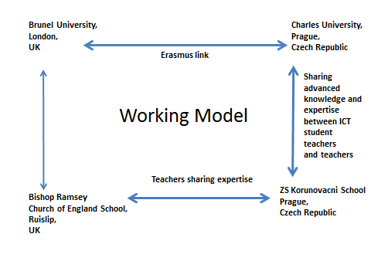

Fig. 1 The Model

4.1 Year 8 Scratch Project at Bishop Ramsey School, London, UK

- To develop computer programming skills using Scratch
- To develop narrative skills using Scratch (not currently developed)
- To publish student learning outcomes (on World Ecitizens) and a project report for teachers (on MirandaNet)
- To explore new ways of collaborating with Brunel University
Objective
Building on Year 7 introductory Scratch work, school pupils, in Year 8 ICT lessons, explored the use of Scratch further to create a piece of narrative work, by creating about ten linked scenes (called Backgrounds). Next, characters (called Costumes) were added to the scenes, and animated, and sound tracks were also added to some project files. This work will be linked, in the next academic year, to Music and Art lessons, following the lead set in Prague.

Method
Introductory lessons were given to Year 8 students by Lawrence Williams, Teaching Fellow at Brunel. The project was explained to staff and pupils, and the tasks were introduced in these lessons. Support for the school from the University was maintained through weekly visits.

Assessment

Following the lesson development, the stories were assessed:
- as successful narrative work (narrative structure, development of characters, use of dialogue, and description)
- as effective (efficient) computer programming
- for cross-curricular elements such as art work (developing the pupils’ own sprites and background scenes), and music (development of sound tracks in music lessons, or as homework)

4.2 International Dimension
Accordingly, Bishop Ramsey School and Brunel University, working together, sent out details of the project to the team in Prague, including some of the support materials developed in the UK. At the Primary School ZS Korunovacni in Prague the project focused on programming stories in Scratch was implemented and adapted for teaching for several groups of pupils in age 8 to 13.

4.3 Teaching Materials Being Developed
Here are some short examples of support materials presented to the students to support the development of their creative work. The Planning Sheet below is vital in order to focus the pupil’s attention on the development of an effective narrative line:

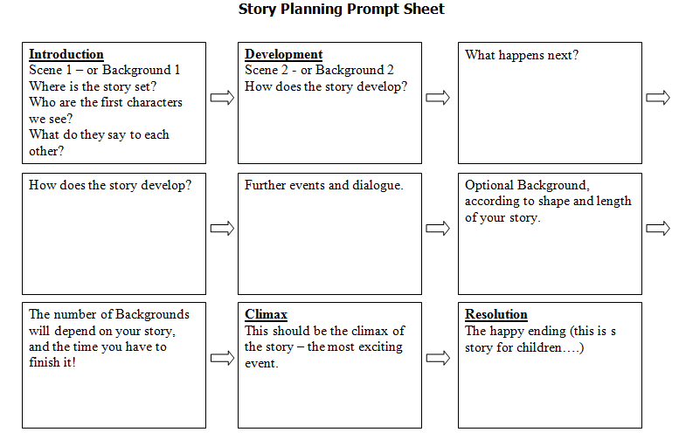
Fig. 2 Story Planning Prompt Sheet

What makes a good story, in Scratch?

Structure

Beginning: Introduce your characters and your setting.

Middle: Develop the story so that it leads up to an exciting climax.

Ending: A resolution, or happy ending, with a moral.

In Scratch, you can place a sentence of narrative across the bottom of each “page”.

Setting
In Scratch, you do not actually need to describe the setting, but you can make your own “backgrounds” against which your story will unfold. Use Draw or Paint.

Characters
Characters: In Scratch, you do not need to describe your characters (called Costumes), but you can show their thoughts and emotions in two ways:

- Speech bubbles
- Thought bubbles (the characters may not be thinking what they are saying….)
You can use or modify sprites from Scratch, or from the Internet, but you can also create your own. Have fun animating your characters! (They are called “Costumes”.)

Music files

You can add music files to add atmosphere to your story. You can use the files from Scratch or from the Internet, but you can also create your own music, using the school’s music software.

Voice-overs

You can use a microphone to add the conversations spoken by the characters in your story.

4.4 Stories in Scratch at ZS Korunovacni, Prague, CZ

The project “Literacy from Scratch” is implemented in ZS Korunovacni six steps:

Step 1
In a compulsory ICT education (1 hour/week) ICT teachers introduce their primary pupils to the use of ICT.
Outcomes: Children are able to switch on and off a computer, to run and exit Scratch, to save data on a server into an appropriate folder.

Step 2
An introduction to the computer science program, Scratch, is added into activities through Art Education. In Art Education the pupils start to formulate, verbally, their first ideas about their stories. A topic of stories should be very close to a child world and interests; it should be interesting also to friends from other countries. It could be stories about a sightseeing tour through Prague with their pets (dogs, cats, ect.). Older pupils, especially boys, prefer topics in which they can apply their fantasy.

Outcomes: Each pupil tells his/her story verbally.

Step 3
In Art Education, pupils elaborate these stories on a paper Story Planning Sheet, with a pencil, both as a series of four scenes with different background both characters (forms) of sprites which communicate together using “bubbles of sentences”. The pupils design on paper also Costumes of sprites. Some pupils seek to design a genuine story with unusual costumes for sprites, therefore they concentrate very much on the quality of the graphic design.

Story Planning Sheet
Scene 1 | Scene 2
Scene 3 | Scene 4

All pupils succeeded in designing visually original characters and figures, embedded very often in unusual stories. This “paper step” is very important. It contributed to visualising ideas and storylines, and to define its four scenes. The visual and graphic forms of stories are original.

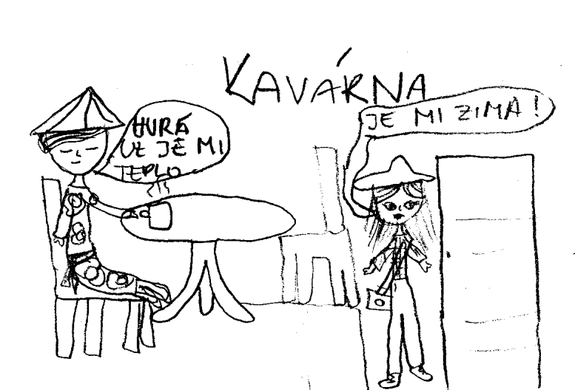
Fig. 3 Example of a scene 3 from the story designed by a pupil of ZS Korunovacni
Some pupils’ design are very complicated, it wouldn’t be easy to draw them in Scratch editor. It is not easy for pupils to develop their story, playing out gradually in four sequences. In this step, children display a dialogue between their sprites mainly through using speech bubbles. A child’s attention is given mainly to the graphic design of sprites and their background. These sketches as we could see later are not so ideal to transfer into Scratch, some of them are scanned by a scanner.
Outcomes: Each pupil develops on a paper a graphic design of the story and sprites.
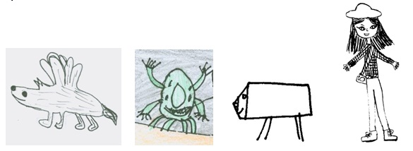
Fig. 4 Examples of some costumes for sprites designed by pupils of ZS Korunovacni
Step 4
When the graphic design of stories and costumes of sprites, drawn by hand, are ready, the pupils describe their stories verbally in an essay form. In this activity, pupils prove their ability to transfer graphic information into verbal form with the aim of explaining what they have drawn. The essay seems to be very important for detailed planning of the stories for programming in Scratch.
Outcomes: Each pupil writes an essay
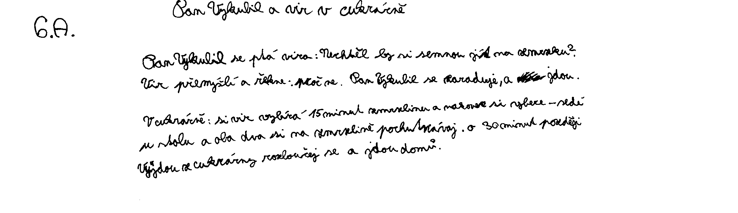
Fig. 5 Example of an essay written by a pupil of ZS Korunovacni (Year 6)

Step 5
In this step, the ICT (ITT) student teacher from the Faculty of Education introduced pupils to programming in Scratch. The main attention was given about how to arrange dialogue in bubbles, how to set sprites into motion, how to create the illusion of walking, flapping wings etc., and how to move from one scene to another one.
Outcomes: Pupils are able to use commands and tools for programming in Scratch, put together some commands in Scratch.

Step 6
Pupils design their stories using skills and knowledge from the Step 5 in Scratch.
Outcomes: Each pupil transforms his/her story scenario in a program in Scratch.

CONCLUSION AND FUTURE DEVELOPMENTS
Already, there is considerable interest in this project. In February 2013, students and teachers from Bishop Ramsey School, with Lawrence Williams, Brunel University, and Dr. Mirka Cernochova, the Charles University, presented stories at the BETT13 Exhibition in London at the MirandaNet meeting.
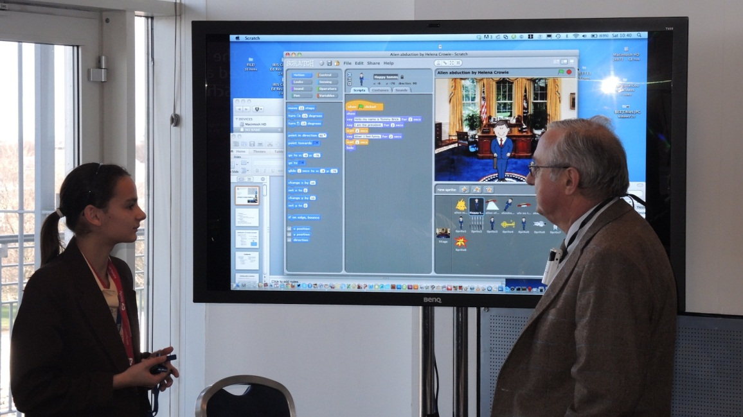
Fig. 6 A Year 8 Bishop Ramsey student presents her story to teachers at BETT13

In March 2013, the project will be presented at the UK’s national Education Show in Birmingham.

The Literacy from Scratch teaching programme is on-going. We plan to publish both a Library of inspirational stories created using Scratch, together with detailed instructions and support files for teachers, when all of the strands have completed their first cycle of development. These will be posted from the World Ecitizens web site, hopefully in a steadily increasing number of languages. The first stories will be in the English and Czech languages.

In both countries, there is a perceived need to develop the project across several different subject areas, so that the stories are well structured by the English or Czech language teachers. Music files can be added as atmospheric additions, and (as in Prague) Art work forms the basis for the creation of Costumes and Backgrounds. There is much work still to be done.

This work was supported by grants of the Czech Science Foundation P407-12-1541 Information Technology Competencies of Children and their Development in Primary and Lower Secondary Schools.

REFERENCES
Note 1. Available on: http://www.worldecitizens.net/projects/curriculum-development/stories-for-children/
Note 2. “Science Through Arts” was presented at WCCE 2005, Cape Town. Available on: http://www.mirandanet.ac.uk/star/star.htm
FEP EE (2007) Framework Education Programme for Elementary Education (with amendments as of 1st September 2007). Research Institute of Education (VÚP) in Prague, 2007.
NEUMAJER, O. (2012) Další vzdělávání učitelů v oblasti ICT. Available on http://spomocnik.rvp.cz/clanek/16139/DALSI-VZDELAVANI-UCITELU-V-OBLASTI-ICT.html.
RAMBOUSEK, V. et al. (2007) Výzkum informační výchovy na základních školách. 1. vydání. Plzeň : Koniáš, 2007. 360 s. ISBN 80-86948-10-2
SGP Baltie http://www.sgpsys.cz/en/
Imagine http://imagine.input.sk/
ZŠ Korunovační http://www.korunka.gns.cz/
Royal Society (2012) Shut down or restart? The way forward for computing in UK schools. January, 2012.

Biography
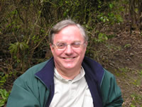 | Lawrence Williams currently teaches in the Graduate School at Brunel University, in west London, following 40 years’ working in south London secondary schools. His interests are in literacy, creative uses of ICT, cross-curricular learning, and international collaborations, on which he has published widely. He has won numerous national and international Teaching Awards, including the Naace 2012 ICT Impact Award: Life Long Achievement.  **This table has a row height of EXACTLY 3.5cm. The first column (for the photo) is 3cm wide and the second column (for the text) is 11.5 cm wide. The photo is x pixels high and y pixels wide.

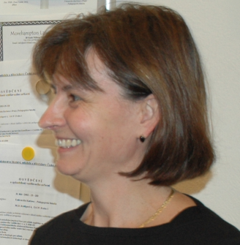
Miroslava Cernochová graduated from the Faculty of Mathematics and Physics at Charles University in Prague. She works for the Faculty of Education at Charles University in Prague at the Dept. of Information Technology and Technical Education where she is responsible for courses focused on ICT applications in teaching and learning (ICT in education, E-learning in school practice, Didactics aspects of Information Education) as a part of the MA Study Programme for ICT student teachers. In 2003-2006 she was invited as an expert to be a member of the Czech Ministry of Education consultative body for realisation of the Governmental Information Policy in Education (GIPE). From 2004 she is a chair of the RDC group "IT and Teacher Education" in the ATEE.

Copyright
This work is licensed under a Creative Commons Attribution-NonCommercial-NoDerivs 3.0 Unported License. To view a copy of this licence, visit http://creativecommons.org/licenses/by-nc-nd/3.0/

http://www.sgpsys.cz/en/
http://imagine.input.sk/
http://www.korunka.gns.cz/
www.tvorivaskola.cz
http://www.korunka.gns.cz/cl1801736408.htm
http://it.pedf.cuni.cz

