_{Algorithms and 5 year olds?}
_{by}
Lawrence Williams and Miroslava Černochová
Many Head Teachers have been dismayed by the seemingly impossible demands of the new Programmes of Study for Computing. Can ICT teachers now, suddenly, develop a wide range of new skills in Computing? Can pupils, aged only 5 years, really understand, write, and debug computer programmes? And, in any case, why should they? What is the point, apart from responding to current political pressures? Here, we argue that pupils really should learn computing (also called computational thinking) as an essential part of their understanding the modern world.
Both children and their teachers have already learned basic digital literacy. However, it is high time to master much more than just how to operate a computer. It is time to learn why and how to use computers for solving problems; to understand what a computer can really do to serve pupils in their learning and discovering; for acquiring knowledge and skills; how to protect themselves from the various risks lurking in a digital world; how to behave in the right way in such a huge cyberspace. In some countries, criticism of teaching focused on computer-user skills’ development (using PowerPoint, and Word) has begun, and has been met in the UK, by the introduction of the new Computing curriculum.

We embrace Seymour Papert’s ideas about children learning with computers: “Learning-by-making” (Papert and Harel, 1991) and Stager’s: “technology as building material, hard fun, learning to make, taking time – proper time for the job. You can’t get it right without getting it wrong.” (Stager, 2007). We believe that it is very important to regard and introduce Computing as a compulsory school subject, and that computational thinking is vital for children’s mental development.

Merely attaining ICT literacy as an aim for school education belongs to the past. It is essential to teach children many skills: to be able to formulate problems, and to select appropriate computer tools and applications; to encourage them to be able to decide independently on the appropriate use of digital technology for problem-solving; to determine whether the problem is solvable using computers; how to collect and analyse data; how to automate data-processing and data-mining. It is, therefore, necessary to focus development on the ability to ask questions; to look for and discover links and contexts; to find relations between different phenomena or events; to inquire about what depends on what, and what does not relate to what; to explain results, and put them into contexts in relation to other facts. Equally, importance must be given to teaching pupils to be able to identify errors in their ways of working, and the processes they use, and to verify the correctness of applied methods and actions. The integration of computational thinking into the curriculum is an opportunity to develop further pupils’ logical thinking. It would be a mistake if we were to develop these abilities of children entirely in subjects about computers, or about computer science, or as a part of a more general computing competency. The Computing initiative, begun in the UK, has opened up a huge amount of professional discussion in the world, directed at the same ends.
But how can this be achieved? Where do we begin? How do we start teachers off on this process of learning to teach computational thinking? Can we easily introduce such concepts to very young pupils? The answer is, “Yes.” A pilot curriculum project, undertaken originally at Bishop Ramsey School, Ruislip (KS3) , and later at the Swaminarayan School in Neasden, West London (KS1), shows very clearly that, given the right support and teaching materials, whole classes of students in Years 1 and 2, can fairly easily fulfil the new UK Computing requirements for the whole of Key Stage 1, and, remarkably, in just over six months. The curriculum project is called “Literacy from Scratch”, and involves pupils being engaged in cross-curricular work (Literacy, Computing, Art, and bilingualism) using the MIT visual computer program, Scratch, to develop block coding skills to create animated stories. It is creative and cross-curricular. And it is fun!

By focussing the pupils’ attention on story-telling, a skill well-understood by Primary teachers, the coding aspect becomes the tool by which the narrative is enabled to unfold. The project is not, in the first instance, actually about computational thinking, but about narrative. Once the pupils are fully engaged in this well-established creative process, however, they find that the only way to present their story effectively is by ensuring that all of the coding is correct. It makes for a positive start to the process of introducing Computing into the school curriculum.
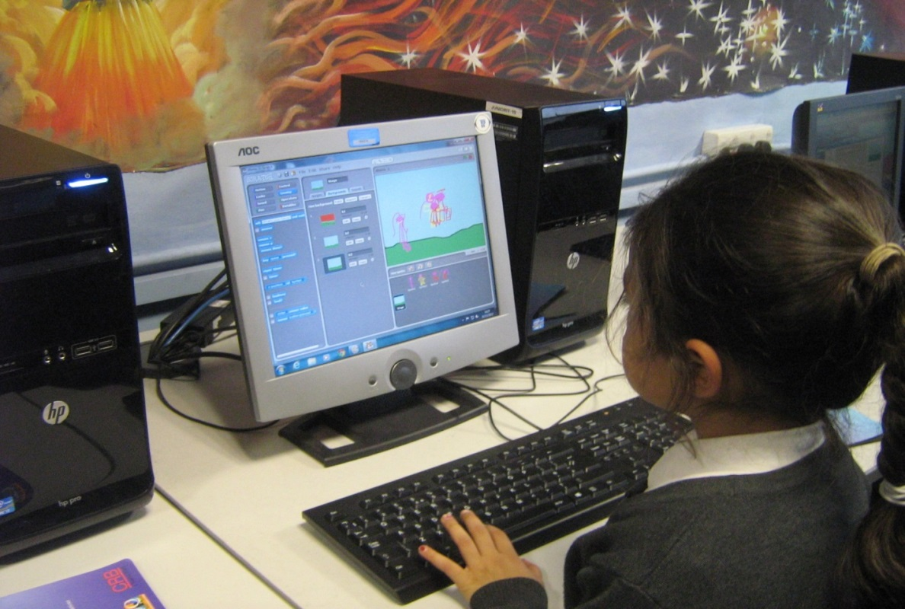
Figure: Key Stage 1 pupil working with Sprites and Backgrounds, using Scratch, to tell her story.
See the Literacy from Scratch web site for teachers, housing teaching support materials, including the KS1 and KS2 students’ completed stories, at:
http://www.literacyfromscratch.org.uk/contact.htm
Lawrence Williams (UK) and Miroslava Černochová (Czech Republic) are ITE trainers, and Senior MirandaNet Fellows
See:

Papert, S., Harel, I. (1991) Situating Constructionism
Available on: http://www.papert.org/articles/SituatingConstructionism.html

STAGER, G. (2007) An Investigation of Constructivism in the Maine Youth Centre. Ph.D. dissertation. University of Melbourne

Forthcoming text:

Introducing Computing: a Guide for Teachers (Ed. L. Williams, Routledge, publication date August 2014)

