Algorithms and 5 year olds?
by
Lawrence Williams
Many Head Teachers have been dismayed by the seemingly impossible demands of the new Programmes of Study for Computing. Can their ICT teachers now, suddenly, develop a wide range of new skills in Computing? Can pupils aged only 5 years really understand, write, and debug computer programmes?
Can pupils:
- understand what algorithms are, how they are implemented as programs on digital devices, and that programs execute by following precise and unambiguous instructions
- create and debug simple programs
- use logical reasoning to predict the behaviour of simple programs
- use technology purposefully to create, organise, store, manipulate and retrieve digital content ?
The answer is quite simple:
Yes.
A pilot curriculum project, undertaken at the Swaminarayan School in Neasden, West London, shows very clearly that, given the right support, whole classes of students, both in Years 1 and 2, can fairly easily fulfil the requirements for the whole of Key Stage 1 above, and, remarkably, in just over six months. The project is called “Literacy from Scratch”, and involves pupils being engaged in cross-curricular work (Literacy, Computing, and Art) using the MIT visual computer program, Scratch, to develop block coding skills to create animated stories.
Here is how it works:
Pupils already need to develop literacy skills, by writing simple stories. A Computing project, based on this idea, therefore builds on class teachers’ existing skills and expertise.
Year 1 Literacy from Scratch project
The Y1 pilot teaching group at Swaminarayan School had already started work, in September, on a series of lessons in the computer room, based around developing basic computer skills, such as using a mouse, logging on to the network, and controlling simple text. It was felt that this series of lessons, Step 1 below, lasting about six weeks, should be completed before the pupils actually started work on Literacy from Scratch.
Step 1: Learn the basics of using a computer on the school network
Discuss the parts of the computer, and what they are used for. Discuss the function of the mouse. Talk about the difference between the mouse on a computer, and using a laptop. Learn how to load programs, such as Scratch and Paint, and how to save files on the school network. Further support for teachers is posted on the Literacy from Scratch web site.
See: www.literacyfromscratch.org.uk
Step 2: Plan a short narrative, in English lessons. Develop this story, using the support materials on the web site.
It was decided that the Year 1 pupils should also create their own Sprites and Backgrounds. Their class teacher then developed their story plans, in their subsequent English lessons. Following this detailed planning work, the pupils were then shown the relevant aspects of computer coding, in Scratch. These included:
- Moving between the scenes (or Backgrounds) each created by the pupils. See image below. On the screen are three Backgrounds, and two Sprites, all created by the pupils.

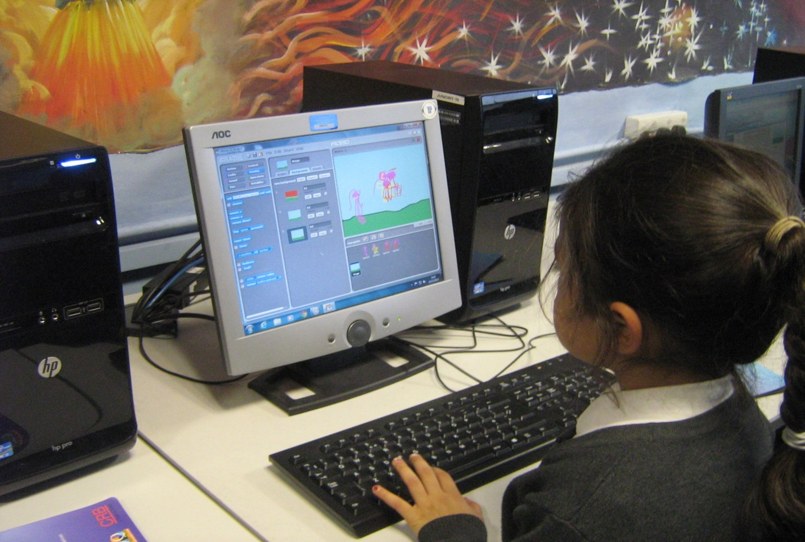

- Making Sprites (or characters) move
- Making Sprites “speak” or “think”
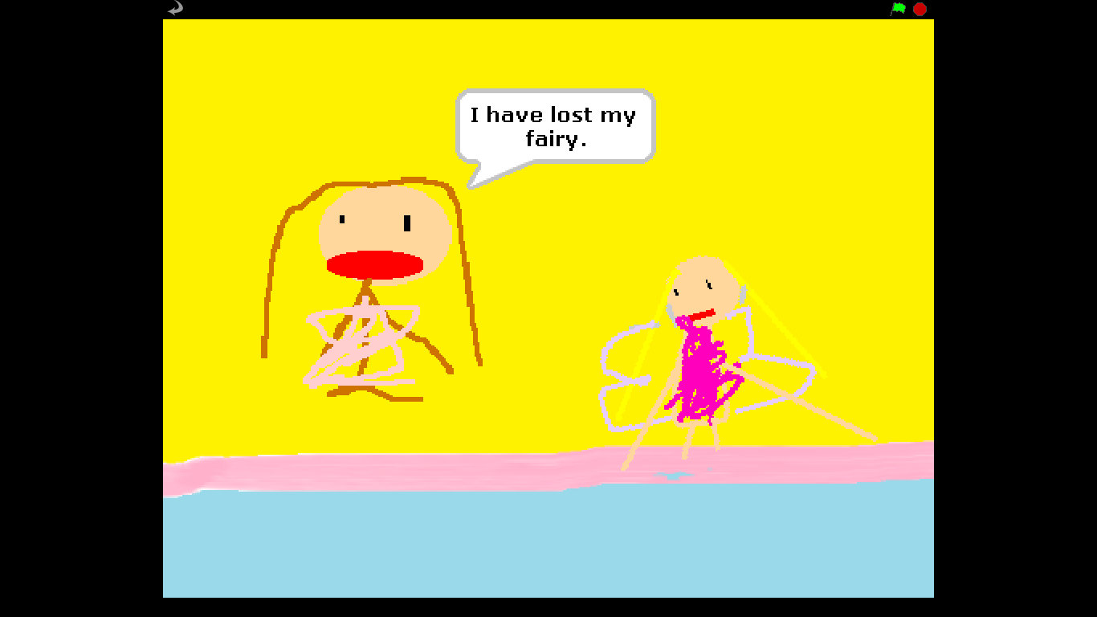
The results of the project were impressive:
All students in the Year 1 and 2 classes completed the following:
In Literacy:
- Writing a very short story in three scenes (Backgrounds) , and creating two characters (Sprites), with simple dialogue
Computing;
- Logging on to the school computer network, using a password
- Loading the Scratch program
- Loading the Paint program
- Using the Paint editor in Scratch to create the pupil’s own two different Sprites (or characters)
- Using Paint to create three Backgrounds (or scenes)
- Retrieving the relevant files from the school network
- Importing the Backgrounds into Scratch
- Using the Control blocks to start the narrative
- Using the Motion blocks to move the Sprites
- Using the Looks blocks to add dialogue
- Saving the work in appropriate areas of the school network
- Logging off properly
The response from the class teachers was very positive.
Year 1 teacher, Donna Roberts, commented, “At times, quite frankly, this process has been somewhat frustrating, with multiple hands in the air, and students calling out, “Miss Roberts! I need your help!” But, I have seen such a massive progression both in their Computing and Literacy skills, in just a few months, that the calls have now become, “Miss Roberts! Look at what I can do!”
Swaminarayan Head Teacher, Mr. Raja, is justly delighted with the success of his young pupils. KS1 Computing as alive and well in west London, in a school which is clearly leading the way.

