Other links
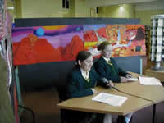
TES article, UK:
http://www.tes.co.uk/article.aspx?storycode=383645
Picture sequence on MirandaNet:
http://www.mirandanet.ac.uk/star/star.htm
Summary article on MirandaNet:
http://www.mirandanet.ac.uk/star/star_article.htm
On-line cross-curricular discussion notes in
Science:
http://www.mirandanet.ac.uk/star/star_sc_web.htm
English:
http://www.mirandanet.ac.uk/star/star_en_web.htm
Religious education:
http://www.mirandanet.ac.uk/star/star_re_web.htm
Other aspects:
http://www.mirandanet.ac.uk/star/star_od_web.htm
Links with Taiwan:
http://www.mirandanet.ac.uk/international/taiwan_star.htm
Links with Satro UK (Science and Technology Regional Office):
http://www.satro.org.uk/usefulresourcesandlinks.html

