‘The World is Calling’.

Professor Preston, UoB, interviews Bob Geldof

Exploring Education Futures
Dr Preston, Professor of Educational Innovation at UoB, interviewed Sir Bob Geldof in a session named after his song, ‘The World is Calling’. This interview was at the opening the four-day international MirandaNet Fellowship event, Exploring Education Futures, in London’s Docklands at the end of January. An amusing and eloquent speaker, Bob regretted that he had gained very little from school. Poetry excited him in English lessons and he can still recite passages he learnt now. But otherwise he found that he had little interest in other subjects and failed to pass any examinations. He admitted he was not easy to manage in school, but also felt that teachers should try to accommodate pupils with his special gifts rather more sympathetically than they treated him.
In terms of technologies, his own children and his wife are more up to date than he is. However, he sees digital innovation as a major force for good as long as new technologies do not wipe out traditional modes of learning. Because of his commitment to alleviating world poverty he invests in GroupCall, a system that gives schools the ability to send text messages (SMS), emails and automated voice calls to the mobile phones and landlines of parents, staff and key contacts as well as text and email messages in anyone of 64 languages. In his view, this method of providing information through mobile devices is particularly important as this is the only way that people in some countries can have access to the modern communications which are so important to learning and autonomy.
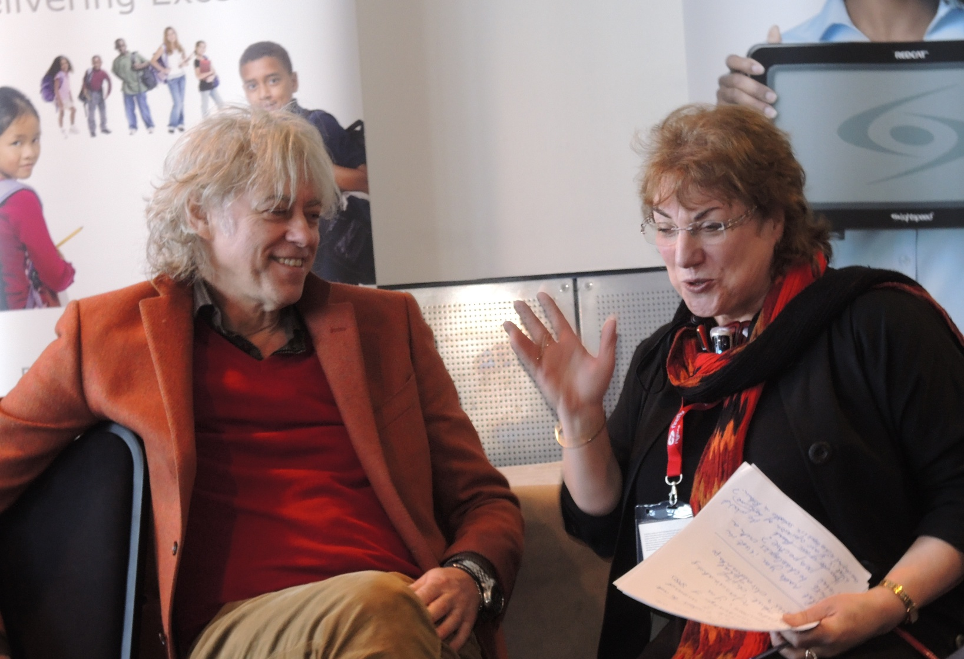

Professor Preston posing questions from the MirandaNet Fellowship members

The ICT Curriculum
A key theme was the ICT curriculum. Notable amongst teachers’ presentations was Literacy from Scratch - a curriculum exchange between Dr Mirka Cernochova from Charles University, Czech Republic and Lawrence Williams from Brunel University, working with Bishop Ramsey School, Ruislip, London. The project developing literacy skills in story telling, uses Scratch, an introductory programming language across the whole of the Year 8 mixed-ability group.
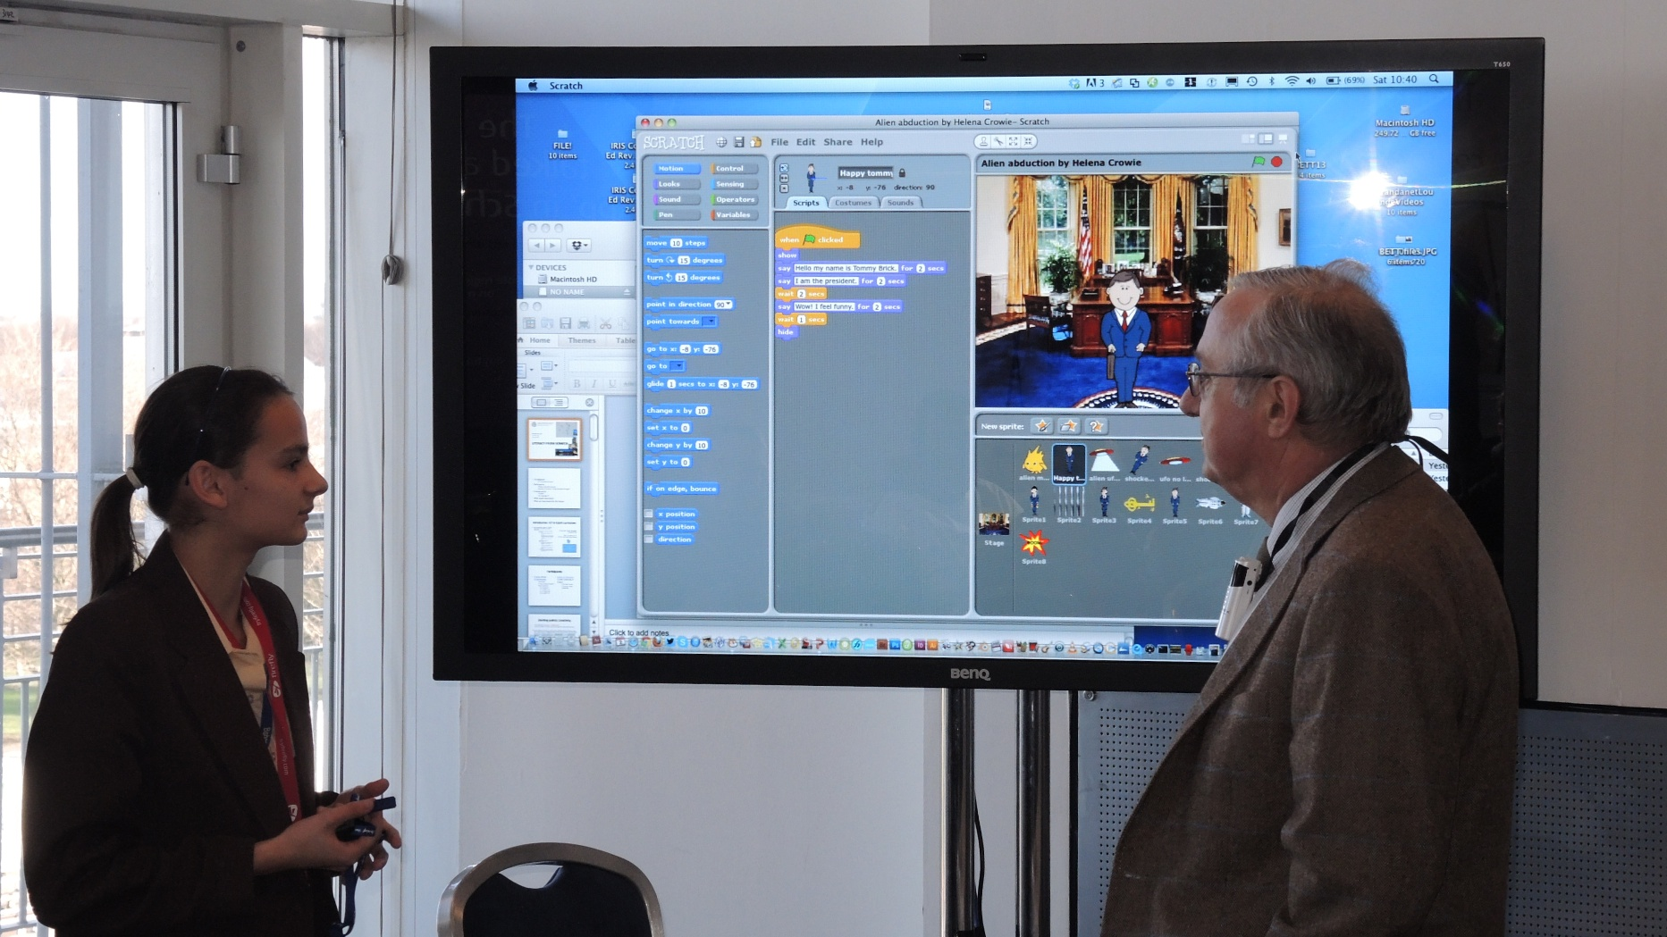

Explaining her story programmed in Scratch
Support materials for other teachers to use are also being written, tested, and developed at the school, and are being sent out for trials in the Czech Republic. The pupils who presented the stories they had programmed were awarded a World Ecitizens certificate for sharing their knowledge with others on this website for pupils’ publications.
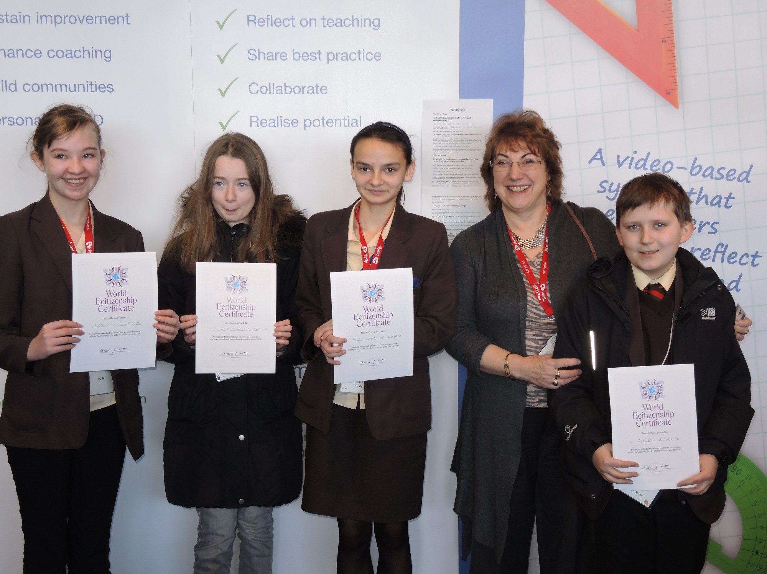

Achieving a World Ecitizens’ certificate for publication

Re-engineering education: a call for collective action
Professor Marilyn Leask, Professor of Educational Knowledge Management and Dr Sarah Younie, both from UoB presented under the theme, An agenda for professional communities: building and sharing professional resources, which was about a global university campaign to collate and publish research about effective teachers’ practice . Their title, ‘Re-engineering education: a call for collective action’ was a response to the OECD (2009) call for the creation of ‘knowledge-rich’, ‘evidence-based’ education systems because in many countries, education is still far from being a knowledge industry in the sense that its own practices are not yet being transformed by knowledge about the efficacy of those practices.
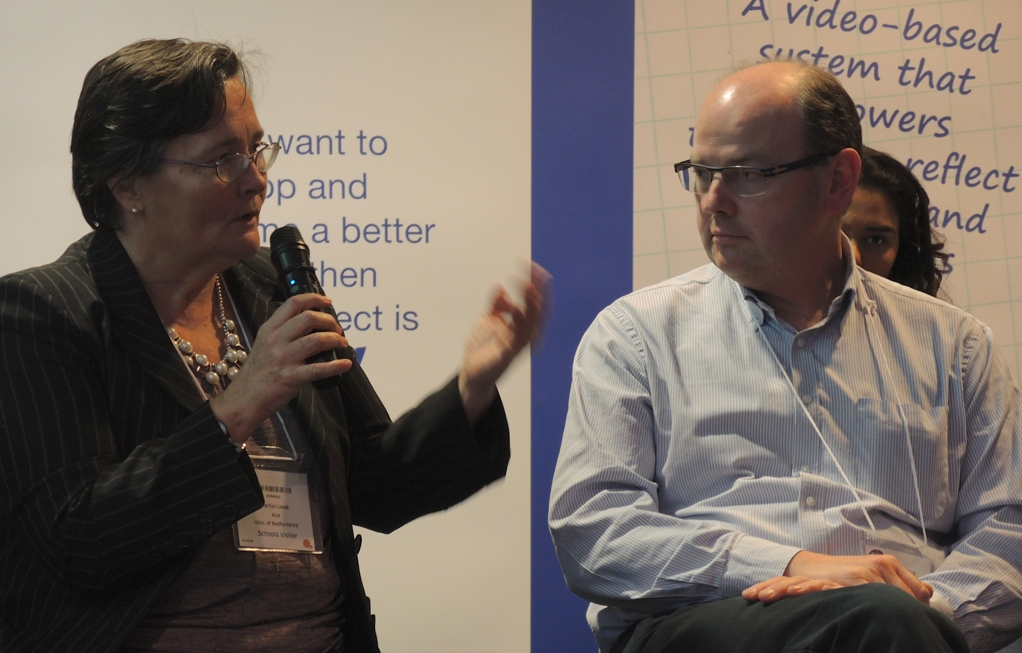

Professor Marilyn Leask debating with Bill Michell, British Computing Society
Through the Education Futures Collaboration, a UoB initiative, Drs Leask and Preston will be extending this global compaign for professional ownership of research data by a speaking tour in New Zealand and Australia in March. They will be encouraging more universities to support a platform that is dedicated to connecting teachers at all levels with summaries and sources of educational research so that professional judgement can be supported with evidence. The need for universities to own their own research information has become pressing since the UK Coalition closed websites that held findings when they came to power in May 2010.

Digital publication after the MirandaNet event
Dr Preston, the founder of the MirandaNet Fellowship, holds this free MirandaNet event at the BETT show every year when UoB students are invited to help as a work experience opportunity. She said that this year had been a particular success as over 250 educators attended to debate some key issues in educational innovation. Participants came from the UK as well as Belgium, Bulgaria, Catalonia, Czech Republic, Emirates, Finland, Germany, Iceland, India, Israel, Holland, Jeddah, Norway, Spain and Sweden. This year the BETT13 associates who sponsored the activities were: GEBOL; Group Call; KO-SU, My Knowledge Map; Oracle; Steljes; Texas Instruments; and, TSM workshops.
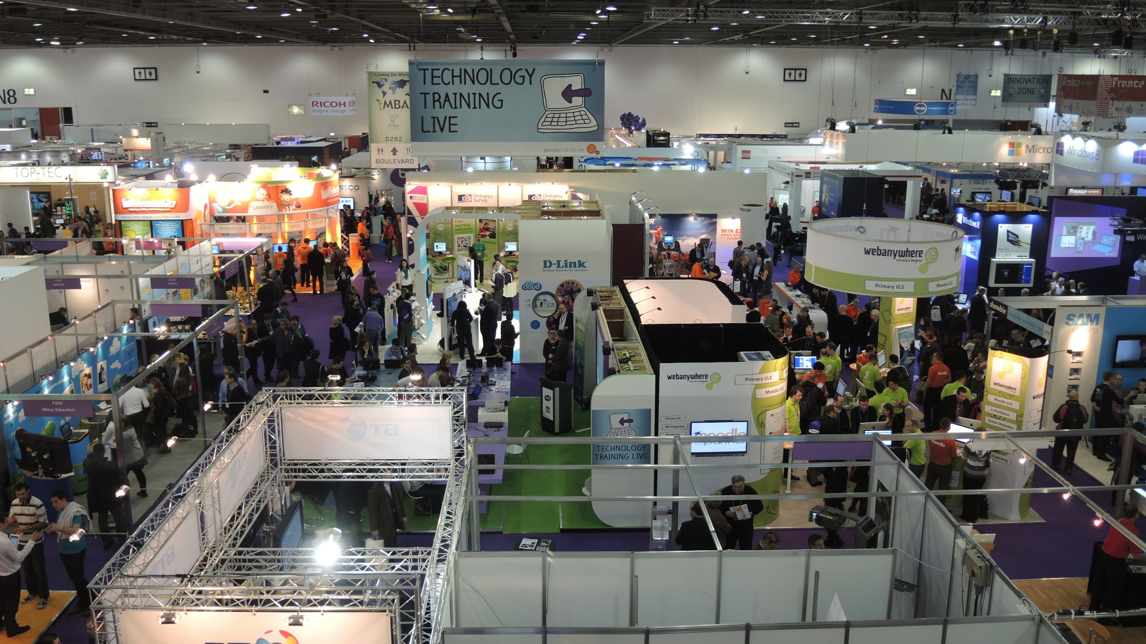
This funding from companies is essential as some of MirandaNet’s policy makers, teachers and researcher members in 80 countries are in remote areas and would not be able to fford a membership fee. Many cannot get to London for a conference either. But they can all view the proceedings video-streamed on line as a result of the donation of high quality classroom sound equipment by LightSpeed and the video equipment and personnel provided by IRIS Connect. Because of this equipment, valuable resources derived from the participation of distinguished speakers and delegates will be published on the MirandaNet website soon, free to all.
EDITORS NOTES
The MirandaNet Fellowship, now in partnership with the University of Bedfordshire and the Education Futures Collaboration, is one of the most highly-regarded influencers in the use of digital technologies to enhance learning and for teacher education in the UK and internationally. It provides a forum where global professionals from different specialisms can share experience, expertise and philosophical approaches about how these digital technologies are best used in teaching and learning. In this international professional organisation of policy makers, educators, developers and researchers’ ideas, theory and practice are exchanged in debate and research studies, case studies and reports are published under the Creative Commons licence aimed at improving the use of innovative digital technologies in classrooms and in professional learning communities.
The Fellowship is a free non-profit making professional organisation boasting more than 800 members in an e-community of practice consisting of international ICT policy makers, teachers, advisers, teacher educators, researchers and commercial developers in over 80 countries. Annual activities are made possible by the voluntary support of members and the contributions of: Classroom Communications, Follett, IRIS Connect and LightSpeed. BETT13 associates included: GEBOL; Group Call; KO-SU, My Knowledge Map; Oracle; Steljes; Texas Instruments; and, TSM workshops. More information about the companies and discussion notes and teaching resources are also available on the MirandaNet website: www.mirandanet.ac.uk

